**Ex1**

1) – Show that $h(n)=\frac{\sin{(}Bπn)}{π.n}$, where 0<B<0.5, is the impulse response (IR) of an ideal low pass filter with cutoff frequency

2) – The figure below represents a version of this impulse response truncated by a P-points Raise cosine window (wc = cos2). Knowing that h(0)=0.125, determine from this figure:

a) –The parity of this IR duration P.

b) - The cutoff frequency $f_{c}$ of this filter.

c) - The duration P of this IR.

d) - The principal lobe width of this IR.

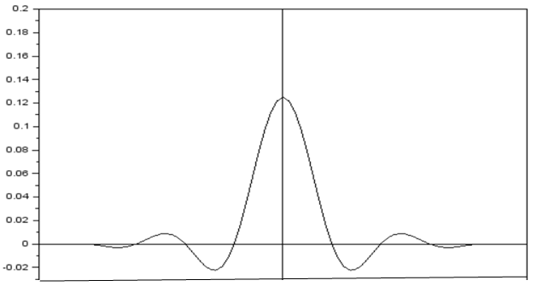

Ex2-Consider the impulse response $h(n)=2\cos{(}2πf_{ce}.n).\frac{\sin{(}Bπ.n)}{π.n}$ of an ideal band pass filter having a pass band width $B$ and a central frequency $f_{ce}$. The following figure represents the result of the truncation of this impulse response (IR) with a window having a duration of P samples.

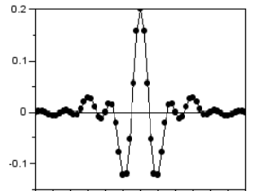

1) -Determine from this figure the value of the pass band width B of this filter.

2) - Knowing that $h(2)=\text{0.0578}$, determine the central frequency

3) -Knowing that the farthest sample is an intersection of this IR and the horizontal axis, determine the duration P of the impulse response of this filter.